`



**COMP1640 Enterprise Web Software Development**

**Group Report**

Tutor:

Name: Hoàng Mạnh Cường

Email: Cuonghmgcs16085@fpt.edu.vn

Class:

|  |  |
| --- | --- |
| Team Name | Group |
| Team members | 1. Hoàng mạnh cường -Scrum Master 2. Chu Chất Bình -Developer 3. Vương Hồng Nhật - Web Designer 4. Bùi Hoàng Thái Minh- Database designer 5. Nguyễn Xuân Hải Đăng - Tester |

Table of Contents

1/ Introduction: 3

Introduction: 3

Introduction about Scrum: 3

2/ Agile Scrum documentation: 5

a. Roles: 5

b. Tools: 5

c. Product backlog 6

d. Meetings 8

1. Sprint planning 8

2. Daily Scrum: 13

3. Sprint review 14

3/ Design documentation: 17

Use case: 17

Database design 21

Wireframe 21

4/ Testing 38

Test plan 38

Test log 38

Test Screenshot 38

5/ Evaluation: 38

Challenges: 38

System weaknesses: 38

System Strengths 38

Learning outcomes. 38

# 1/ Introduction:

Today with the development of education, there are many different forms of learning invented and improved to improve the quality of teaching, teaching online is such a model, this model helps teachers and students. Can exchange with each other more easily without going to class. Online learning helps students reduce the cost of courses that make it easier for them to acquire knowledge, online learning also helps teachers can transfer more knowledge through saved online lectures. and teachers can earn extra income through this. However, the current online teaching programs are still incomplete and there are many shortcomings that is why we made this topic for the project. We will try to address the shortcomings and shortcomings of the existing programs, we named this site an electronic tutor.  
We hope to be helpful in improving online learning and online management through this project.

## Introduction about Scrum:

**Scrum**

In order to create this project, we will apply the scrum model to help our team operate the most effectively, helping the plans be completed on time and with high efficiency.

Scrum framework haves 3 core values: transparency, inspection and adaptation.

**Transparency**

Transparent information is a big issue to note, all team members are responsible for sharing information with each other, including research information, information about what they have completed. Like the difficulties they are facing, this helps team members understand the progress of the project and easily help each other solve problems while developing software. The plan must be made in detail so that the team members can understand their role and complete according to the plan.

**Inspection**

Each week, there will be meetings to report the deadline and share information among the individuals in the group. The purpose of this is so that the whole group can know the information and progress of the project, know the difficulties we are facing are aimed at solving together quickly. Gather more information to improve the project.

**Adaptation**

Adaptation is a flexible form of handling situations while working on a project, the adaptability and development of this project is based on the team's testing, this data must be shared with all members. to help them adapt to the project as quickly as possible

**Roles in Scrum:**

**Product owner**

Each function must be carefully researched and grasped, the product owner is the one who decides whether the function is right or not, and the person who decides whether or not the project will work.

**Development Team**

The Development Team is the project developers, they are the main coders in the team, who design the functions according to SC's requirements and plans.The development team has a project development role.

**Scrum Master**

Scrum master is the person in charge of the group, who has a planning and planning role for the members of the team. The Scrum master must manage the progress of the plan, engage everyone to help the plan develop smoothly.

**Sprint:**

**Planning**:   
Through the requirement table of the SC project, a plan will include the necessary functions of the project, SC will make its own evaluation of the complexity of each function and give a time to complete it appropriately. The Srum model allows for flexible adaptation of the project based on the development context of the project, allowing developers to flexibly change the development plan .

**Review:** After making the plan, the whole group will meet and consider whether the plan is reasonable or not, and revise it to make an official plan.

**Retrospective:** The project will be developed based on SC's plan and SC will work with team members to resolve project issues..

**Daily Scrum:** Each day the group will meet for 15 minutes to give information of each person in the group, the difficulties will be presented and solved together.

**Tools of Scrum:**

**Product backlog:** We use the Trello tool to manage a list of functions that are implemented based on the plan proposed by SC. It helps us to know the priority, progress of the function as well as which functions have completed.

**Sprint backlog:** The sprint backlog is a checklist in the trello that helps us break down the conditions based on priority from low to high to solve it according to the level of necessity of the project.

**Burndown chart:** The Burndown chart is a chart created based on parameters from meetings between product owner and team, it will be drawn from high to low functions, ensuring the conditions for making the plan as well as deadline. It will be a tool to track the deadline of each function, it is one of the standards of scrum and is commonly used.

# 2/ Agile Scrum documentation:

1. Roles:

Roles of each member in team:

Hoàng mạnh cường -Scrum Master

Nguyễn Xuân Hải Đăng-Developer

Vương Hồng Nhật - Web Designer

Bùi Hoàng Thái Minh- Database designer

Chu Chất Bình- Tester Tools:s

The tools of Agile Scrum will be used:

Agile Scrum tools:  
- Product Backlog: Write down the requirements in the application.  
- Sprint Backlog: the stages and tasks in each sprint  
- Burndown Chart: Representing the process of group activities

1. Product backlog

<https://trello.com/b/zlt5Qpw5/comp1640-enterprise-web-softw>

**As a student**

As a student, I need to have a system for communicating and exchanging information with teachers.

As a Student, I need to have a system for organizing meetings

As a Student, I need to have a system for uploading documents

As a Student, I need to have a system of review of resources

As a Student, I need to have a blogging system

As a Student, I need to have an email system to send teachers  
As a Student, I can email to teacher about is to be used only for notification of events recorded in the backend database

As a Student, I need the interface must be suitable for mobile phones, tablets, desktops

**As a tutor**

As a tutor, I need to have a system for communicating and exchanging information with teachers.

As a tutor, I need to have a system for organizing meetings

As a tutor, I need to have a system for uploading documents

As a tutor, I need to have a system of review of system

As a tutor, I need to have a blogging system

As a tutor, I need a personal calendar to be able to be placed in classes that fit their schedule

As a tutor, I need to have an email system to send students

As a tutor, I need Teachers can email students about is to be used only for notification of events recorded in the backend database

As a tutor, I need the interface must be suitable for mobile phones, tablets, desktops

**As an admin**

As an admin, I need Authorised staff will have access to the dashboards of other staff, and to individual dashboards for students.

As an admin, I need Student and staff data is accessed from the university MIS system. The maintenance of this is outside the scope of this project.

As an admin, I need Admin can assign rights to tutors and cancel their rights for students

As an admin, I need Students and tutors will receive notification emails if there is a change in student or tutor

As an admin, I need Admin can allocate a large number of students at the same time to 1 teacher

As an admin, I need admin can cancel many student at a time in a teacher's classroom

As an admin, I need the interface must be suitable for mobile phones, tablets, desktops

**Activities**

**Student**

* All students and their tutors are to use the eTutor system for messaging, arranging and recording meetings (both real and virtual), uploading documents and commenting on them, and for blogging.
* All students must have a personal tutor
* Each student will have their own personal dashboard summarising their interaction with their personal tutor.
* Email between students and their personal tutors is to be used only for notification of events recorded in the backend database. No other content is to be sent via email
* The interface must be suitable for all devices (eg mobile phones, tablets, desktops)

**Tutor**

* All students and their tutors are to use the eTutor system for messaging, arranging and recording meetings (both real and virtual), uploading documents and commenting on them, and for blogging.
* Each tutor will have a personal calendar to be able to be placed in classes that fit their schedule
* Email between students and their personal tutors is to be used only for notification of events recorded in the backend database. No other content is to be sent via email.
* The interface must be suitable for all devices (eg mobile phones, tablets, desktops)

**Admin**

* Any authorised member of staff can allocate or reallocate personal tutors to students. The student and the personal tutors will get notification emails when this happens.
* Bulk allocation of students to their personal tutor (eg 10 at a time) needs to be implemented.
* Authorised staff will have access to the dashboards of other staff, and to individual dashboards for students.
* Student and staff data is accessed from the university MIS system. The maintenance of this is outside the scope of this project.

1. Meetings
2. Sprint planning

**Sprint 1:**

Located: School library

Day: 20-2 -2020

Time: 10.00 AM

**Attendance**

1. Hoàng mạnh cường -Scrum Master
2. Chu Chất Bình-Developer
3. Vương Hồng Nhật - Web Designer
4. Bùi Hoàng Thái Minh- Database designer
5. Nguyễn Xuân Hải Đăng - Tester

**Agenda**

* Discuss and make task to be performed

Hoàng mạnh cường: We to create database first, login form and register after that and we create interface of this app.

All member: Agree

* Time to develop

Man 2: We will create database from 20/2/2020 to 25/2/2020, next we will create login form and register from 26/2/2020 to 1/3/2020 and we create interface from 2/3/2020 to 5/3/2020

All member: Agree

* Role of each member in team.

Bùi Hoàng Thái Minh: I will create database

Vương Hồng Nhật: I will design interface

Chu Chất Bình: I will create login and register

Hoàng mạnh cường: I will review database

Nguyễn Xuân Hải Đăng : I will test login and register functions.

* Task for each member

Bùi Hoàng Thái Minh: Create database

Vương Hồng Nhật: Design interface

Chu Chất Bình: Create login and register

Hoàng mạnh cường: Review database

Nguyễn Xuân Hải Đăng : Test login and register functions.

* Execution Time

Create database from 20/2/2020 to 25/2/2020

Create login form and register from 26/2/2020 to 1/3/2020

Create interface from 2/3/2020 to 5/3/2020

Test and review 6/3/2020 – 7/3/2020

* End Time: 11h00 AM.

Spring Backlog of Sprint 1:

|  |  |  |  |  |  |  |  |  |
| --- | --- | --- | --- | --- | --- | --- | --- | --- |
| Sprint 1 | Point | Dev’s  Name | Begin | End | Act Begin | Act End | Act Point | Notes |
| Create database | 4 | Bùi Hoàng Thái Minh | 20/2/2020 | 25/2/2020 |  |  |  |  |
| Create login form and register from | 3 | Chu Chất Bình | 26/3/2020 | 1/3/2020 |  |  |  |  |
| Create interface | 3 | Vương Hồng Nhật | 2/3/2020 | 5/3/2020 |  |  |  |  |
| Test and review and test login | 2 | Hoàng mạnh cường.  Nguyễn Xuân Hải Đăng | 6/3/2020 | 7/3/2020 |  |  |  |  |

**Sprint 2:**

Located: School library

Day: 8/3/2020

Time: 9.00 AM

**Attendance**

1. Hoàng mạnh cường -Scrum Master
2. Chu Chất Bình -Developer
3. Vương Hồng Nhật - Web Designer
4. Bùi Hoàng Thái Minh- Database designer
5. Nguyễn Xuân Hải Đăng - Tester

**Agenda**

* Discuss and make task to be performed

Hoàng Mạnh Cường: We must to analysis requirement in outline and proceed it with 1-4 level for each user like student, tutor, admin. After that we design maintenance data, analysis system, create decentralization system.

All member: Agree

* Time to develop

Nguyễn Xuân Hải Đăng : We will proceed function with 1-4 level for each user from 8/3/2020 to 20/3/2020 , next we will design maintenance data from 21/3/2020 to 22/3/2020 and we create analysis system from 23/3/2020 to 24/3/2020 after that we create decentralization system from 25/3/2020 to 26/3/2020

All member: Agree

* Role of each member in team.

Chu Chất Bình: I will proceed function with 1-4 level for Student

Bùi Hoàng Thái Minh: I will design maintenance data

Vương Hồng Nhật: I will create analysis system

Hoàng mạnh cường: I will decentralization system

Nguyễn Xuân Hải Đăng : I will proceed function with 1-4 level for tutor and admin.

* Task for each member

Chu Chất Bình: Proceed function with 1-4 level for Student

Bùi Hoàng Thái Minh: Design maintenance data

Vương Hồng Nhật: Create analysis system

Hoàng mạnh cường: Decentralization system

Nguyễn Xuân Hải Đăng : Proceed function with 1-4 level for tutor and admin.

* Execution Time

Proceed function with 1-4 level for each user from 8/3/2020 to 20/3/2020

Design maintenance data from 21/3/2020 to 22/3/2020

Analysis system from 23/3/2020 to 24/3/2020

Create decentralization system from 25/3/2020 to 26/3/2020

* End Time: 11h00 AM.

Sprint Backlog of Sprint 2:

|  |  |  |  |  |  |  |  |  |
| --- | --- | --- | --- | --- | --- | --- | --- | --- |
| Sprint 2 | Point | Dev’s  Name | Begin | End | Act Begin | Act End | Act Point | Notes |
| Proceed function with 1-4 level for Student | 4 | Chu Chất Bình | 8/3/2020 | 20/3/2020 |  |  |  |  |
| Design maintenance data | 3 | Bùi Hoàng Thái Minh | 21/3/2020 | 22/3/2020 |  |  |  |  |
| Analysis system | 3 | Vương Hồng Nhật | 23/3/2020 | 24/3/2020 |  |  |  |  |
| Create decentralization system | 4 | Hoàng mạnh cường | 25/3/2020 | 26/3/2020 |  |  |  |  |
| Proceed function with 1-4 level for tutor and admin. | 4 | Nguyễn Xuân Hải Đăng | 27/3/2020 | 30/3/2020 |  |  |  |  |

Sprint 3:

Located: Coffee Shop

Day: 30/3/2020

Time: 9.00 AM

**Attendance**

1. Hoàng mạnh cường -Scrum Master
2. Chu Chất Bình -Developer
3. Vương Hồng Nhật - Web Designer
4. Bùi Hoàng Thái Minh- Database designer
5. Nguyễn Xuân Hải Đăng - Tester

**Agenda**

* Discuss and make task to be performed

Hoàng mạnh cường: This sprint mission is perform IDs from 5-8, create date and time format, create email system for tutor and student, create account for student, create email system work, create account for tutor. Write document, upload system, blog system.

All member: Agree

* Time to develop

Bùi Hoàng Thái Minh: This sprint mission is perform IDs from 5-8, create date and time format from 4/4/2020 to 5/4/2020, create email system for tutor and student 4/4/2020 to 5/4/2020, create account for student 4/4/2020 to 5/4/2020, create email system work 4/4/2020 to 5/4/2020, create account for tutor 4/4/2020 to 5/4/2020.

All member: Agree

* Role of each member in team.

Hoàng mạnh cường: I will create date and time format

Vương Hồng Nhật: I will create account for student and tutor

Bùi Hoàng Thái Minh: I will create email system for tutor and student

Chu Chất Bình: I will create upload system, blog system and Write document.

Nguyễn Xuân Hải Đăng : I will Test and review.

* Task for each member

Hoàng mạnh cường: Create date and time format

Vương Hồng Nhật: Create account for student and tutor

Bùi Hoàng Thái Minh: Create email system for tutor and student

Chu Chất Bình: create upload system, blog system and Write document

Nguyễn Xuân Hải Đăng : Test and review.

* Execution Time

Create date and time format from 4/4/2020 to 5/4/2020

Create email system for tutor and student 4/4/2020 to 5/4/2020

Create account for student 4/4/2020 to 5/4/2020

Create upload system, blog system and Write document 4/4/2020 to 10/4/2020

Create account for tutor 4/4/2020 to 5/4/2020.

End Time: 11h00 AM.

Sprint Backlog of Sprint 3:

|  |  |  |  |  |  |  |  |  |
| --- | --- | --- | --- | --- | --- | --- | --- | --- |
| Sprint 3 | Point | Dev’s  Name | Begin | End | Act Begin | Act End | Act Point | Notes |
| Create date and time format | 5 | Hoàng mạnh cường | 4/4/2020 | 5/4/2020 |  |  |  |  |
| Create account for student and tutor | 5 | Vương Hồng Nhật | 4/4/2020 | 5/4/2020 |  |  |  |  |
| Create email system for tutor and student | 3 | Bùi Hoàng Thái Minh | 4/4/2020 | 5/4/2020 |  |  |  |  |
| Create upload system, blog system and Write document | 4 | Chu Chất Bình | 4/4/2020 | 10/4/2020 |  |  |  |  |
| Test and review. | 4 | Nguyễn Xuân Hải Đăng | 4/4/2020 | 5/4/2020 |  |  |  |  |

1. **Daily Scrum**:

Our team exchanged information on ZALO, we talked about the difficulties as well as solutions to those difficulties to ensure the plan in each sprint. In addition to exchanging on ZALO, we have meetings meet face-to-face with each week in a coffee shop as well as in the classroom, at which point the team members will directly share their issues and help other friends. All activities is make sure the project will be on schedule.

1. **Sprint review**

The Sprint Review Meeting.

Sprint 1:

Sprint 1 evaluation:

|  |  |  |  |  |  |  |  |  |
| --- | --- | --- | --- | --- | --- | --- | --- | --- |
| Sprint 1 | Point | Dev’s  Name | Begin | End | Act Begin | Act End | Act Point | Notes |
| Create database | 4 | Bùi Hoàng Thái Minh | 2/3/2020 | 7/3/2020 | 2/3/2020 | 7/3/2020 | 4 |  |
| Create login form and register from | 3 | Chu Chất Bình | 11/3/2020 | 10/3/2020 | 11/3/2020 | 10/3/2020 | 5 |  |
| Create interface | 3 | Vương Hồng Nhật | 11/3/2020 | 14/3/2020 | 11/3/2020 | 14/3/2020 | 4 |  |
| Test and review | 2 | Hoàng mạnh cường.  Nguyễn Xuân Hải Đăng | 14/3/2020 | 15/3/2020 | 14/3/2020 | 15/3/2020 | 5 |  |

Review:

All stories set out to be completed on time in the plan, all tasks are completed.

Sprint 2:

Sprint 2 evaluation:

|  |  |  |  |  |  |  |  |  |
| --- | --- | --- | --- | --- | --- | --- | --- | --- |
| Sprint 2 | Point | Dev’s  Name | Begin | End | Act Begin | Act End | Act Point | Notes |
| Proceed function with 1-4 level for Student | 4 | Chu Chất Bình | 15/3/2020 | 30/3/2020 | 15/3/2020 | 30/3/2020 | 5 |  |
| Design maintenance data | 3 | Bùi Hoàng Thái Minh | 11/3/2020 | 10/3/2020 | 11/3/2020 | 10/3/2020 | 4 |  |
| Analysis system | 3 | Vương Hồng Nhật | 1/4/2020 | 2/4/2020 | 1/4/2020 | 2/4/2020 | 4 |  |
| Create decentralization system | 4 | Hoàng mạnh cường | 3/4/2020 | 4/4/2020 | 3/4/2020 | 4/4/2020 | 3 |  |
| Proceed function with 1-4 level for tutor and admin. | 4 | Nguyễn Xuân Hải Đăng | 15/3/2020 | 30/3/2020 | 15/3/2020 | 30/3/2020 | 4 |  |

Review:

There were some problems in sprint 2 that made progress at some stage delayed but it was still on schedule and all tasks assigned were completed on schedule.

Sprint 3:

Sprint 3 evaluation:

|  |  |  |  |  |  |  |  |  |
| --- | --- | --- | --- | --- | --- | --- | --- | --- |
| Sprint 3 | Point | Dev’s  Name | Begin | End | Act Begin | Act End | Act Point | Notes |
| Create date and time format | 5 | Hoàng mạnh cường | 4/4/2020 | 5/4/2020 | 4/4/2020 | 5/4/2020 | 5 |  |
| Create account for student and tutor | 5 | Vương Hồng Nhật | 4/4/2020 | 5/4/2020 | 4/4/2020 | 5/4/2020 | 4 |  |
| Create email system for tutor and student | 3 | Bùi Hoàng Thái Minh | 4/4/2020 | 5/4/2020 | 4/4/2020 | 5/4/2020 | 5 |  |
| Create upload system, blog system and Write document | 4 | Chu Chất Bình | 4/4/2020 | 10/4/2020 | 4/4/2020 | 10/4/2020 | 3 |  |
| Test and review. | 4 | Nguyễn Xuân Hải Đăng | 4/4/2020 | 5/4/2020 | 4/4/2020 | 5/4/2020 | 4 |  |

Review:

In Sprint 3, at each Story, the actual completion time is one day different from the time set, since this is one of the days that are relevant to the deadline of other subjects of the group members, so the progress degree has not been guaranteed. However, the Story has also been fully implemented.

Conclusions:

For a number of factors such as deadline for other subjects, illness, personal work, etc., in some sprints, the actual time of each Story has been deviated from the expected time at each Sprint. However, the Story set out is still completed in a relatively good way.

1. Project Burn down chart

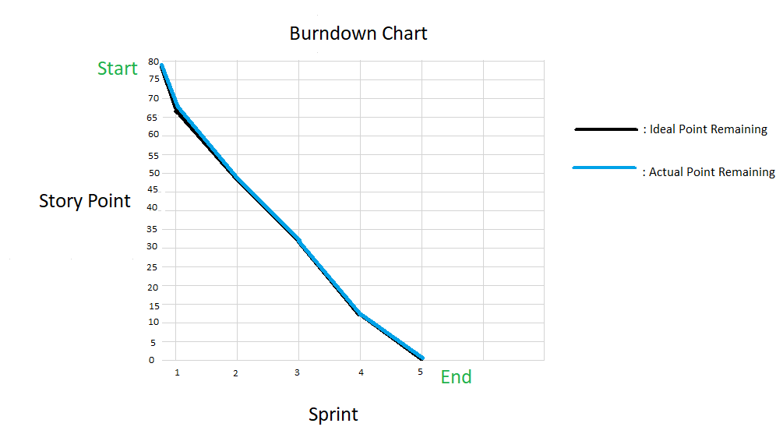

Figure: Burndown Chart

Description:

Burndown chart helps the whole team to see the real progress of the project. Describing the figure above, on the vertical axis, will be the story points that were raised in each Sprint, after calculating the sum of the Story Points in each Sprint, we will start from point 78. On the horizontal axis, are the sprints we have outlined. The black line shows the planned process, while the blue one is the actual process. After each Spring period, Point will decrease, the chart will have a downward pattern, which is why it is called Burndown chart.

# 3/ Design documentation:

## Use case:

Admin:

Figure: Use case for Admin 

Description:

* As an admin, I need Authorised staff will have access to the dashboards of other staff, and to individual dashboards for students.
* As an admin, I need Student and staff data is accessed from the university MIS system. The maintenance of this is outside the scope of this project.
* As an admin, I need Admin can assign rights to tutors and cancel their rights for students
* As an admin, I need Students and tutors will receive notification emails if there is a change in student or tutor
* As an admin, I need Admin can allocate a large number of students at the same time to 1 teacher
* As an admin, I need admin can cancel many student at a time in a teacher's classroom
* As an admin, I need the interface must be suitable for mobile phones, tablets, desktops Information.

**Tutor**:



Figure: Use case for tutor

Description:

* As a tutor, I need to have a system for communicating and exchanging information with student.
* As a tutor, I need to have a system for organizing meetings
* As a tutor, I need to have a system for uploading documents
* As a tutor, I need to have a system of review of system
* As a tutor, I need to have a blogging system
* As a tutor, I need a personal calendar to be able to be placed in classes that fit their schedule
* As a tutor, I need to have an email system to send students
* As a tutor, I need Teachers can email students about is to be used only for notification of events recorded in the backend database
* As a tutor, I need the interface must be suitable for mobile phones, tablets, desktops

**Student:**



Figure: Use case for Student

Description:

* As a student, I need to have a system for communicating and exchanging information with teachers.
* As a Student, I need to have a system for organizing meetings
* As a Student, I need to have a system for uploading documents
* As a Student, I need to have a system of review of resources
* As a Student, I need to have a blogging system
* As a Student, I need to have an email system to send teachers
* As a Student, I can email to teacher about is to be used only for notification of events recorded in the backend database
* As a Student, I need the interface must be suitable for mobile phones, tablets, desktops

## Database design

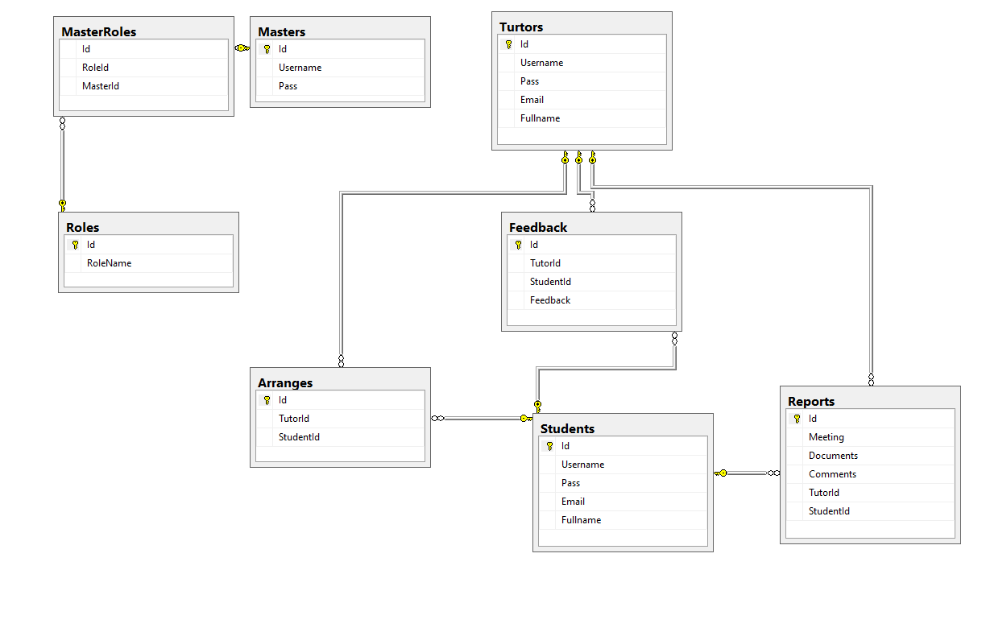

Figure: Entity Relationship Diagram.

Description:

This is the relationship between tables, the master role will be linked to the master and the master role through the ID with the n-n link.

Students and tutors are linked together through arranges and n-n relations. Students, reports and tutors are linked together in an n-n connection .TusTor, feedback and students are linked together in n-n links.

.

## Wireframe

1. **Student**
2. Home page

Wireframe:

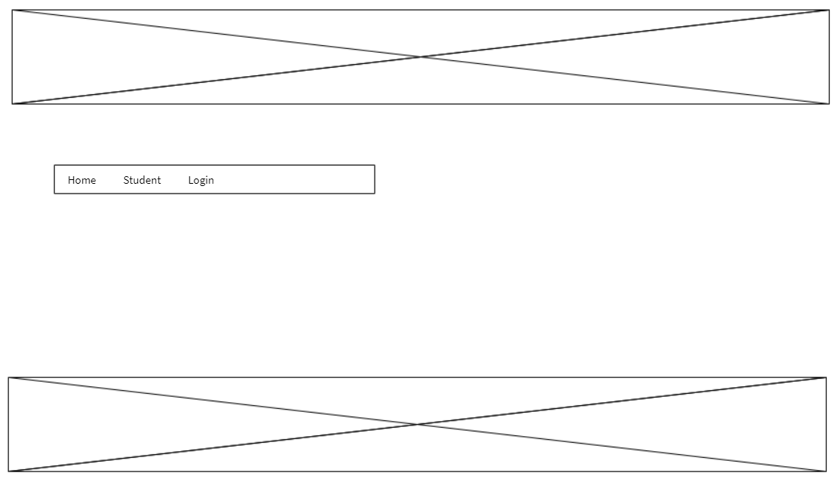

Reality:

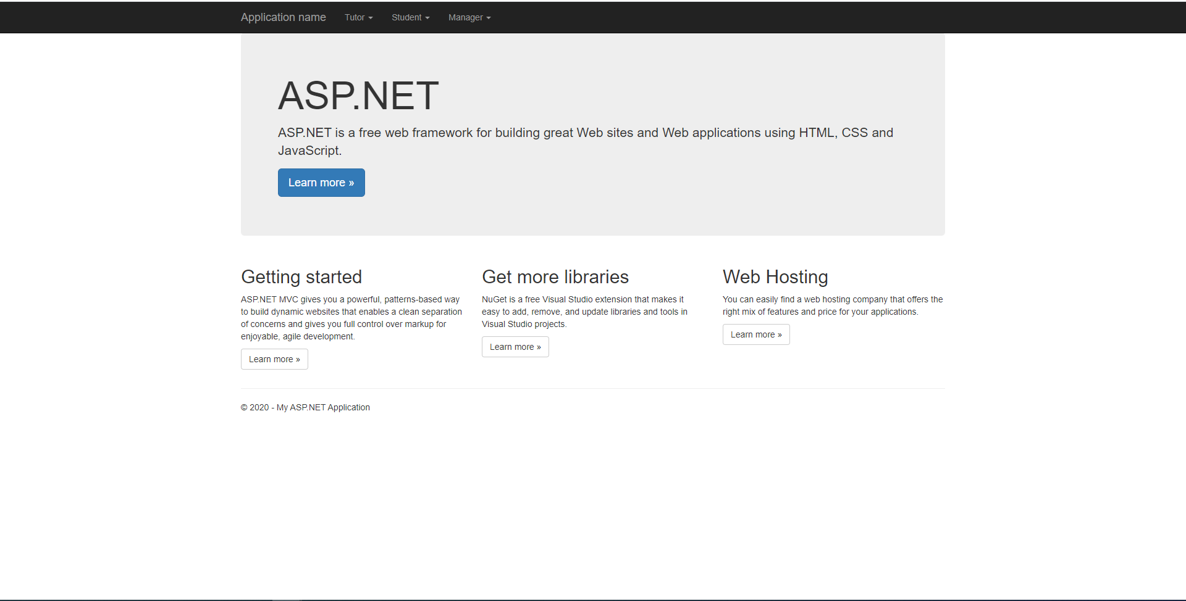

1. Register Page for Student

Wireframe:

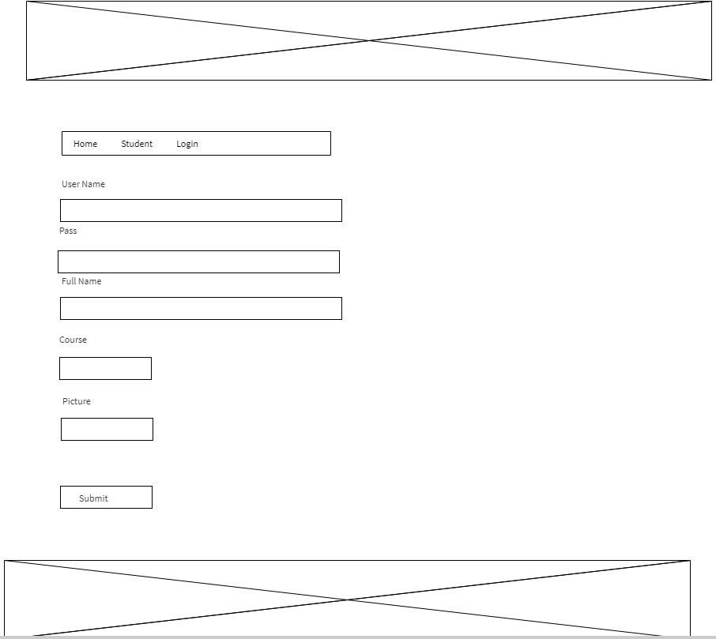

Reality:

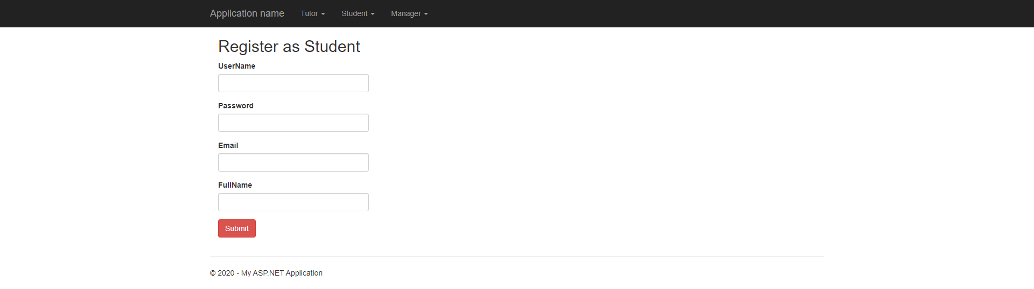

1. Login page as Student

Wireframe:

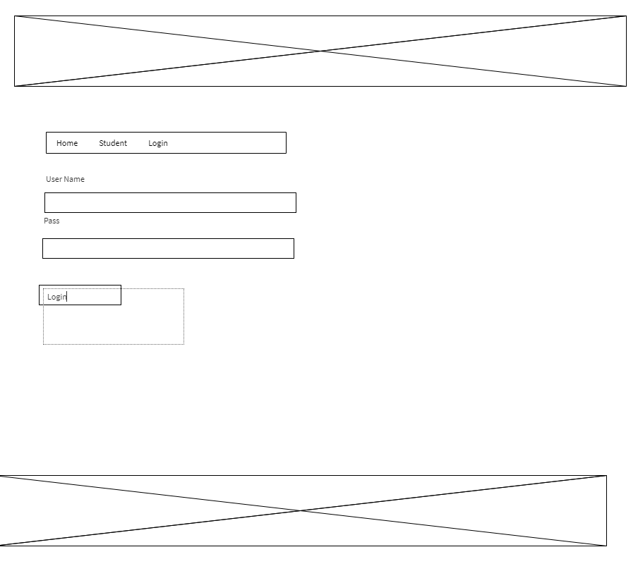

Reality:

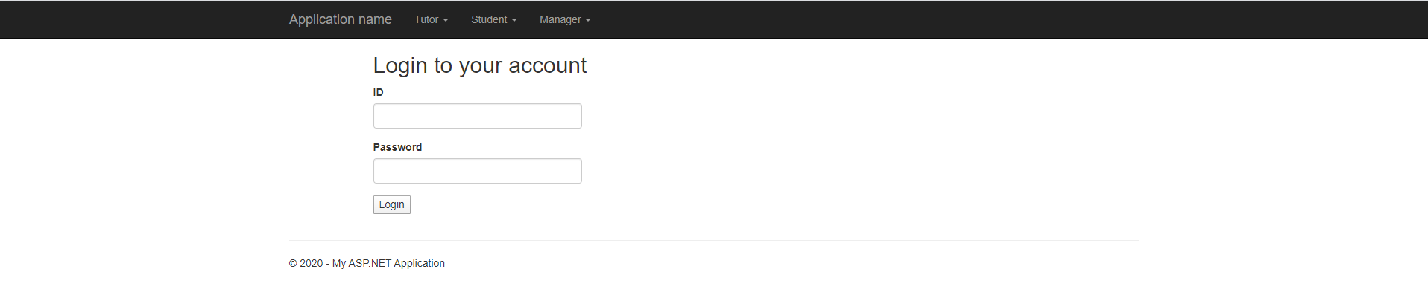

1. Post feedback

Wireframe:

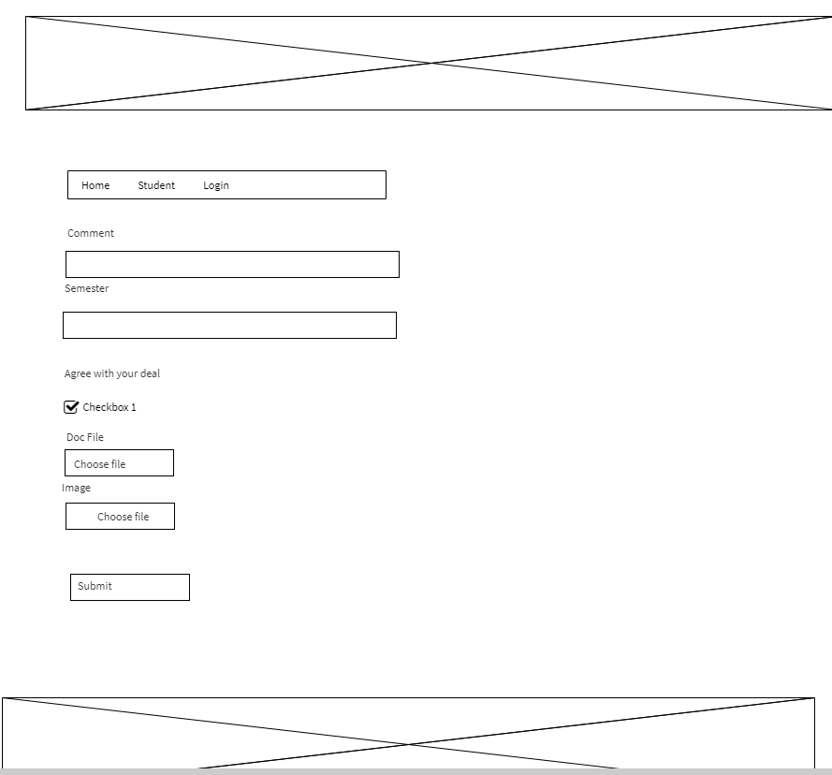

Reality:

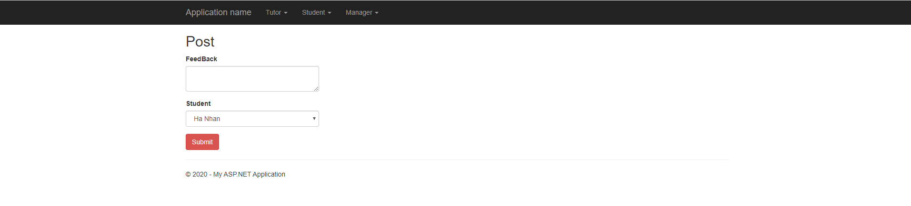

1. **Tutor**

Register Page for tutor

Wireframe:



Reality:

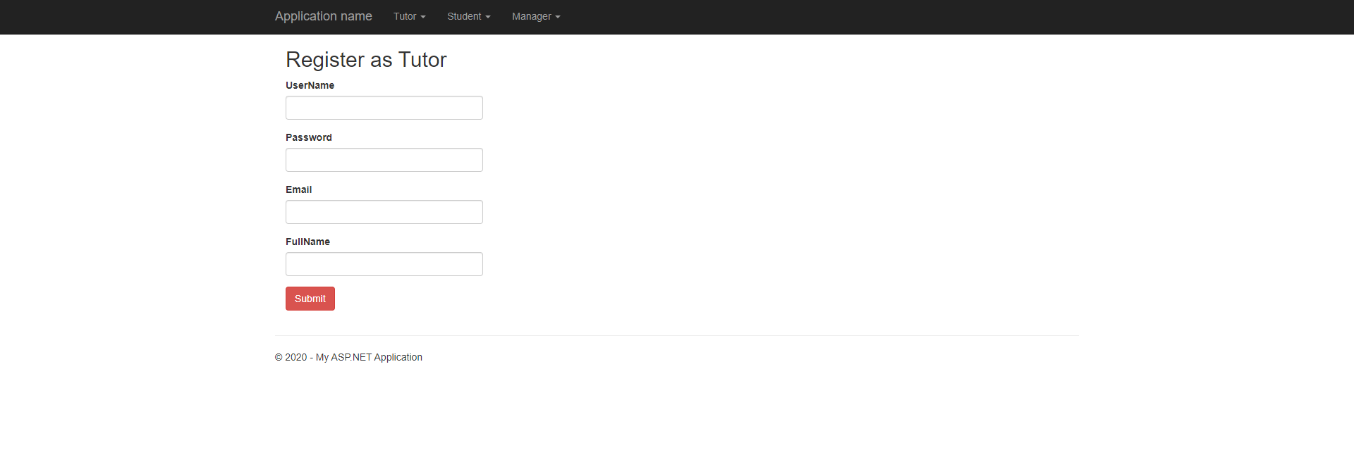

1. Login page as tutor

Wireframe:



Reality:

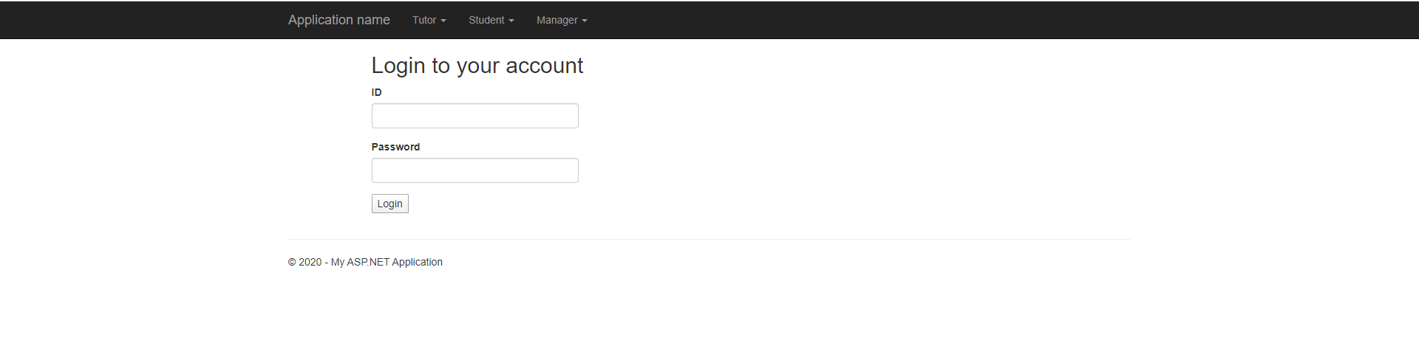

1. Post document for tutor

Wireframe:



Reality:

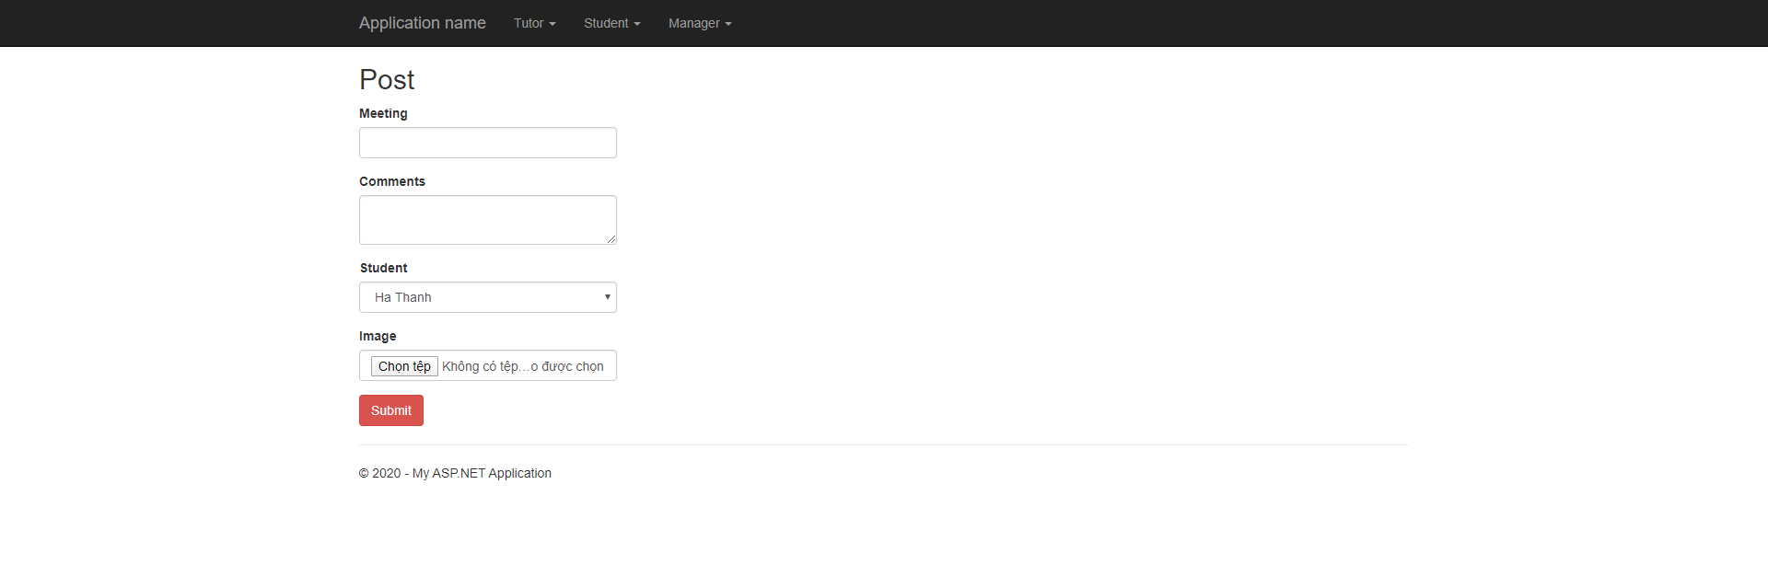

**3 Admin**

1. Student management

Wireframe:

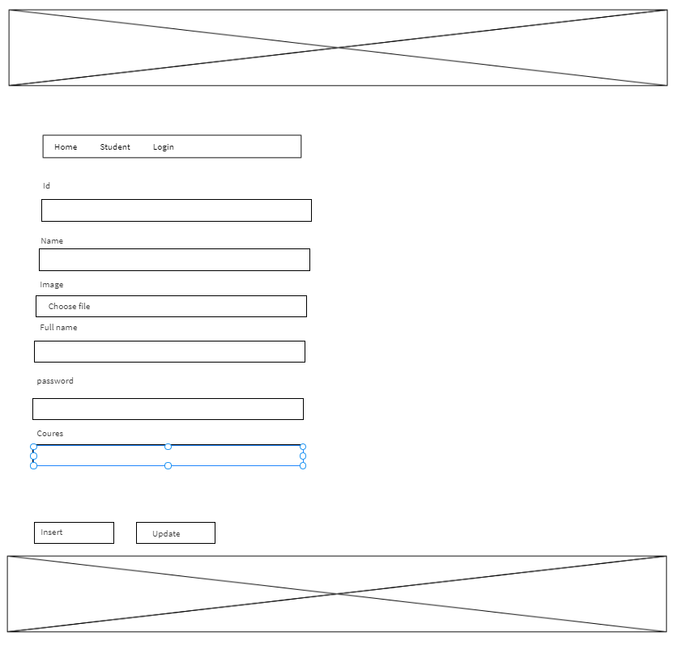

Reality:



1. Decentralizing teachers and students

Wireframe:

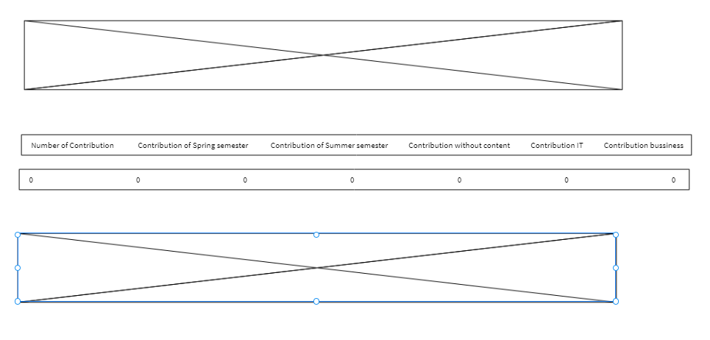

Reality:

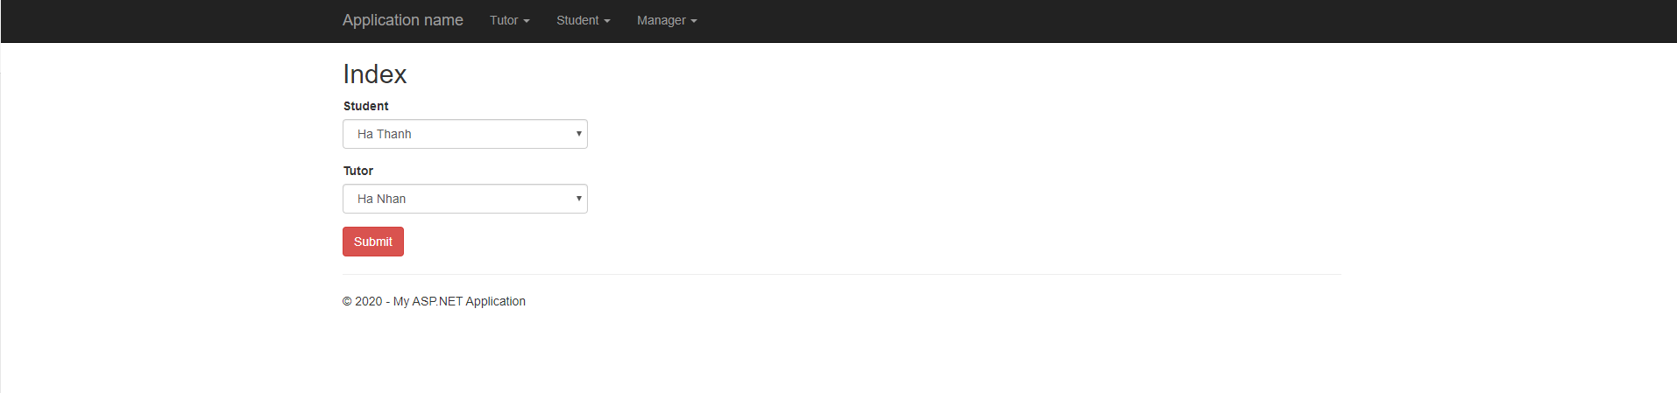

Evaluation:

Compared to the description in the Wireframes, the design after completion has a design that closely resembles what the whole group has imagined about the application. Although this is an eye-catching design, it seems to me that its functions still meet the requirements set out in Sprints.

# 4/ Testing

## Test plan

|  |  |  |  |
| --- | --- | --- | --- |
| **No** | **Test function** | **Description** | **Status** |
| 1 | Login | Student login, tutor login, admin login | Pass |
| 2 | Log out | Student logout , tutor logout, admin logout | Pass |
| 3 | System for communicating and exchanging information between teacher and student | Chat system, email system.  We try to chat and communicating and exchanging information between teacher and student. | Pass |
| 4 | System for organizing meetings between teacher and student | Teamview, meeting online class, call system.  We try to test organizing meetings between teacher and student | Pass |
| 5 | uploading documents  for student | Upload document system, we try to test uploading documents for student | Pass |
| 6 | uploading documents  for tutor | Upload document system, we try to test uploading documents for tutor | Pass |
| 7 | Student email system | Test send email for tutor | Pass |
| 8 | blogging system for student and teacher | Test upload blog and document for tutor and student | Pass |
| 9 | Personal calendar for tutor | Test create personal calendar for tutor, edit and delete it | Pass |
| 10 | Tutor email system | Test send email for student and admin | Pass |
| 11 | Student system of review of resources | Feedback test for admin or tutor | Pass |
| 12 | Tutor system of review of system | Feedback test for admin | Pass |
| 13 | Admin Authorised staff | Test Authorised staff will have access to the dashboards of other staff, and to individual dashboards for students. | Pass |
| 14 | data is accessed from the university MIS system | Student and staff data is accessed from the university MIS system. The maintenance of this is outside the scope of this project. | Pass |
| 15 | Manage tutor | Admin can assign rights to tutors and cancel their rights for students | Pass |
| 16 | Manage email system | Students and tutors will receive notification emails if there is a change in student or tuto | Pass |
| 17 | Admin allocate student and tutor | Admin can allocate a large number of students at the same time to 1 teacher | Pass |
| 18 | interface must be suitable for mobile phones, tablets, desktops | Test interface of application on mobile phones, tablets, desktops | Pass |

## 5/ Evaluation:

## Challenges:

The difficulties we encountered when doing that were during the development process, we had a hard time concentrating on our ability to implement the website because the members had too many deadlines to do. Therefore, most functions are almost as satisfying as the requirement has been set, but the interface design is still not very eye-catching and some points need to be improved. Because too many deadlines are at the same time, the progress of the sprints is in fact more time-consuming than expected by the team.

## System weaknesses:

After completing the website, I realized that our application has some of the following weaknesses:

* Student can’t comment
* Student can’t contact with others student
* Marketing Coordinator can’t contact with other Marketing Coordinator
* Admin can’t get feedback from student about Marketing Coordinator or manager

## System Strengths

After completing the website, I realized that our application has some of the following strengths:

* My application can be handles almost problem
* This application can help student submit their reports, image with high quality easy and quickly, they can view without register account, they can use student guess account
* Admin can manage all users and roles, admin can be view statistical analysis and manage all course.
* All report can be download by Zip file.
* Each kind of account have role which are setup by admin and it just seen what admin want they seen.

## Learning outcomes.

After finish of this task, I have taken in a great deal about working aptitudes, capacity to talk about, trade, critical thinking, I found that every one of my speculations, examine, no doubt esteem. Allude to Wikipedia for SCRUM Agile techniques stress the accompanying: Working programming is esteemed more than documentation. Group cooperation is progressively significant over contract exchange. Reacting to change could easily compare to following an arrangement I have a decision, a working gathering scrum, individuals should continually associated with one another consistently, to guarantee the advancement of work, fixing botches immediately experienced